Your MATP Service

In Philadelphia County, the MATP program is managed by ModivCare formally LogistiCare Solutions, LLC. We offer transportation services via van rides, bus passes and gas reimbursement to Medicaid recipients.

People receiving Medical Assistance may get
rides to medical and/or mental health services from the Medical Assistance Transportation Program (MATP). For more information about getting rides in Philadelphia County, please call ModivCare at 1-877-835-7412. Our office hours are 6:00 a.m. – 8:00 p.m., Monday – Saturday.

Q. Who can receive transportation to medical and/or mental health appointments?

A. Rides to medical/mental health appointments and related services are for people who are on Medical Assistance and need help paying for a ride. Your medical problem should not be an emergency.
If you have an emergency, you should call 911 for help right away.

Q. When should I call for a ride?

A. Call at least 72 business hours for a van ride or 7 days for a bus pass to your medical appointment. If you do not call at least 72 hours/7 days before, it may be harder for you to get transportation. You can get transportation with less than 72 hour’s notice, only for special trips, such as when a person needs tests at the hospital right away. The number to call for a ride is
1-877-835-7412. The TTY number is 1-866-268-6198

Q. Who decides what kind of ride I will get?

A. ModivCare will ask you questions about
your health and the kinds of things you can
do. Your answers will help us decide what
kind of vehicle you need. A SEPTA bus or train might be the best choice for your ride. If it is, we will send you a bus or train pass before your trip.
If you are able to use your own car or you
know someone who can give you a ride, we will pay you $0.25 per mile, plus parking and tolls.

Q. Who can call to ask for a ride?

A. You can call to ask for a ride, or someone in your family, or a person who takes care of you can call for you. Your medical office can also call.

Q. What if I do not speak English?

A. ModivCare provides translation services free of charge. You may also ask for written information in your language of choice.

Q. How do I get rides for trips that I need to take on a regular schedule, like to dialysis?

A. Tell a ModivCare customer service person what you need. They will call your medical office and ask them to send us a form that says you need regular rides. We will make sure that you get the rides until you or your medical office tells us you don’t need them anymore.

Q. What if my ride is late, I need to cancel or there is some other problem with my ride?

A. If your ride is more than 15 minutes late, you need to cancel your ride or there is some other problem you should call our Where’s My Ride line at 1-877-835-7420. We will do everything we can to help you.

Q. What if I want to complain about my ride or another part of the service?

A. If you have a problem or a complaint with your ride or service call us at 1-877-835-7428 and we will help you.

Q. May I appeal a decision made by
ModivCare such as changing or stopping my service or any other issues that I may have?

A. Yes. ModivCare will send you a letter that explains your right to appeal. The letter will tell you the reasons for our decision and how you can appeal it. You can get free legal help with your appeal from Community Legal Services Welfare Law Line at 215-227-6485 or the Pennsylvania Health Law Project at 1-800-274-3258.

Remember:

• All rides must be for a medical or mental health service that is covered by Medical Assistance, like a doctor, dentist, treatment center, therapist, pharmacy, etc.

• You must ask for transportation at least 72 hours/7 days before you need it.

• Have your name, date of birth, address and phone # ready when you call for transportation.

• Try to be ready at least 15 minutes before your ride is scheduled to arrive. Look and listen for the vehicle if you can.

Reservations – 1-877-835-7412
Where’s My Ride – 1-877-835-7420
Complaints – 1-877-835-7428
TTY – 1-866-268-6198

FOR MORE INFORMATION ON
MATP VISIT THE PENNSYLVANIA DEPARTMENT OF HUMAN SERVICES WEBSITE: matp.pa.gov

What to expect from ModivCare

• Polite and quick service when
scheduling your trips.

• Free translation services when
calling our offices.

• A timely, safe ride in a clean vehicle with a courteous and friendly driver.

• Respect for your needs and assistance in scheduling your rides.

• Written response to your complaints.



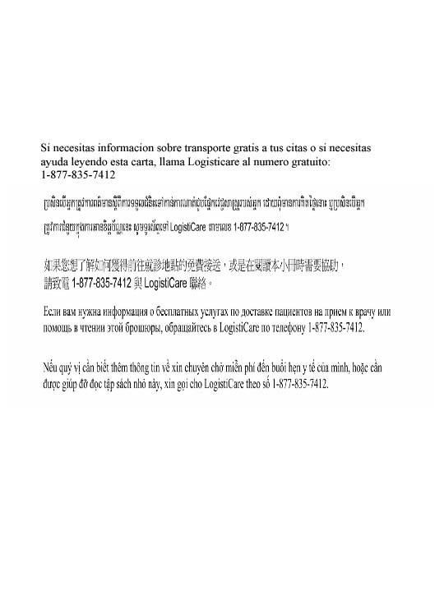
For more information about MATP in Philadelphia County call ModivCare at 1-877-835-7412.





How to Use

Philadelphia MATP

Transportation Services

For Medical Assistance

Recipients



